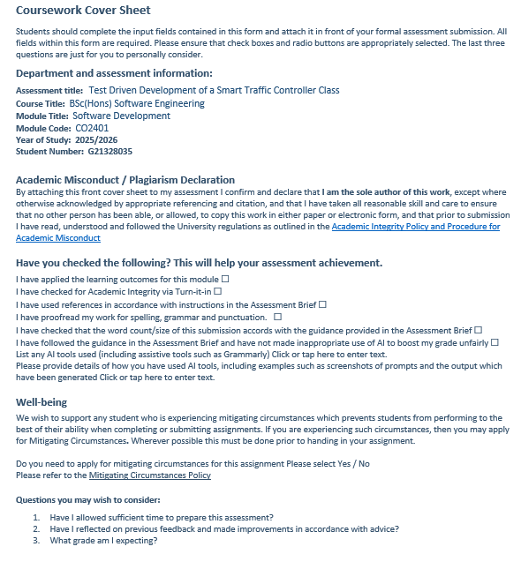
CO2401 Software Development Assignment
  - Test Driven Development of a Smart Traffic Controller Project: A Reflection Report

Introduction
The report is a reflection on the creation of a Smart Traffic Controller system as part of the CO2401 Software Development course. It was necessary to use Test-Driven Development (TDD) to implement a TrafficController class in C#. The class also controls vehicle signals (red, redamber, green, amber, oosv) and pedestrian signals (wait, walk, oosp), legal state transitions, and five hardware dependencies, and does fault detection and maintenance logging.
Tools and technology used during the project were: C# (.NET) was the implementation language, Visual Studio 2022 was the development environment, NUnit 4.3.2 was the unit testing framework, NUnit3TestAdapter 5.0.0 to run tests in Visual Studio, NUnit.Analyzers 4.7.0 to analyze test code statically, NSubstitute 5.3.0 as the mocking and isolation framework, Microsoft.NET.Test.Sdk 17.14 to execute tests in Visual Studio and coverlet.collector 6.0.4

What?
The task involved writing and unit testing the unit, the TrafficController, in TDD including tests with the necessary behavior written first and then the production code produced afterwards.

Level 1 - Core Constructor and State Management
I started with single-parameter constructor (L1R1, L1R2) asserting that the passing of the single parameter to the constructor “JUNCTION_A”resulted in GetIntersectionID() returning “junction_a”. This did not start initially, which I fixed by invoking id.ToLower() within the body of the constructor which started me on the road to red-green-refactor cycle. L1R3 needed SetIntersectionID() to also lowercase; I wrote a test with mixed case input with a parameterised test before I wrote the method. L1R4 needed vehicle and pedestrian signals to be defaulted as “amber” and “wait” respectively. On L1R5 (SetStateDirect), I used [TestCase] attributes to test all five/valid vehicle states, all three/pedestrian states and invalid values and ensured that the method returned false and did not change state when using invalid values.

Level 2 - State Transitions and Dependency Injection
State transition enforcement was added by L2R1. Writing tests for illegal transitions before implementing the logic was highly effective - the tests acted as a live specification.To keep the logic short and verifiable, I used a fixed dictionary VehicleTransitions of states to their one legal successor (amber –> red –> redamber –> green -> amber). I also discovered that the system should impose the pedestrian state on the system, for example the red -> redamber transition should always leave the pedestrian in the “walk” state no matter what the caller claims. This was confirmed by a parameterised test.

L2R2 needed a three-parameter constructor that causes an ArgumentException on an invalid start state. I have created a test that states the entire exception message string verbatim as in the brief. This promptly detected a punctuation anomaly I had created, which, otherwise, would have passed the secret exams of the marker.

The six-parameter dependency injection constructor was added in L2R3. The TrafficController could then be tested fully in isolation of the actual hardware using NSubstitute 5.3.0 stubs, for example _vehicleSignalManager.SetAllRed(true).Returns(true). New substitutes were generated in [SetUp] prior to each test thus eliminating the possibility of one test configuration influencing another.

Level 3 - Hardware Calls, Fault Detection, and Email Fallback
The most complicated requirements were L3R1 and L3R2. The amber to red transition required ITimeManager.Delay(3) first, then SetAllRed(true), SetWalk(true), and SetAudible(true), followed by a 60-second hold via Delay(60).First implementation was a wrong name of SetAllRed(true) and then Delay(3). This was immediately caught by a test with the following: A test with timeManager.Delay(3).Returns(false) did not change the state as it was expected and the bug in ordering was exposed.

History state and out of service entry were introduced in L3R3. WebService.FaultDetected(true) is called to the first call as SetCurrentState(“oosv”, “oosp”) - this only causes the system to commit to the oosv/oosp state when it returns true. I added historyVehicleState and historyPedestrianState fields which take a snapshot of the pre-OOS state. It was tested that the following steps to enter OOS: green/wait then SetCurrentState(“green”, “wait”) are correct, and following the steps results the system in the previous condition.

L3R4 needed GetStatusReport() to invoke IWebService.LogEngineerRequired() and a comma-separated list of bad device types. I asserted the specific string sent to the web service by using the following _webService.Received(1).LogEngineerRequired("VehicleSignal,PedestrianSignal,")

Email fallback was needed so that L3R5 could handle the exception that LogEngineerRequired threw. I simulated the exception with the .When().Do() pattern of NSubstitute to ensure that IEmailService.SendMail () was called with recipient transportoffice@gmail.com, subject “failed to log out of service” and the exception message in the body. The test initially failed due to swapping subject and message arguments which was immediately picked up by mock verification.

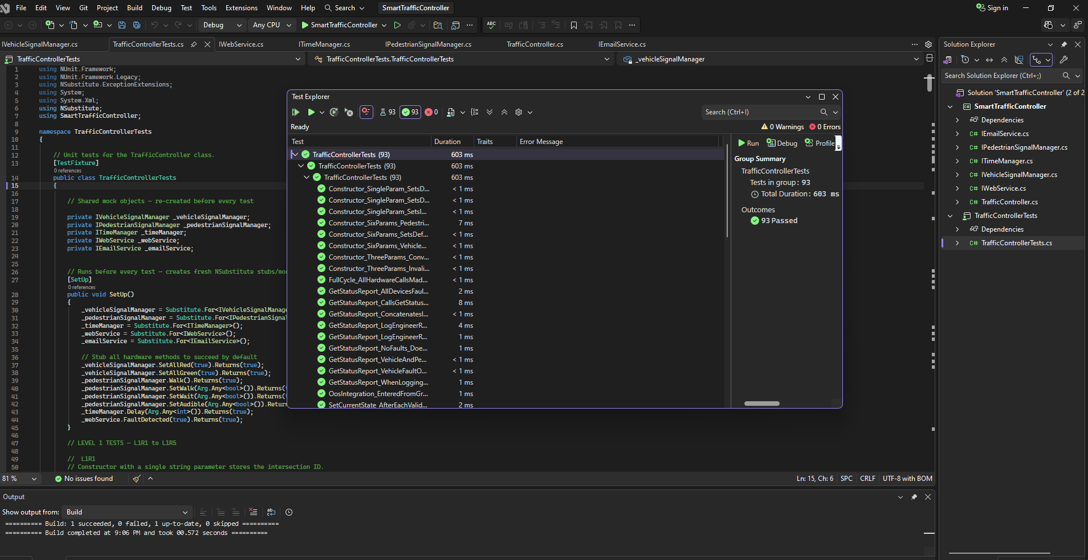
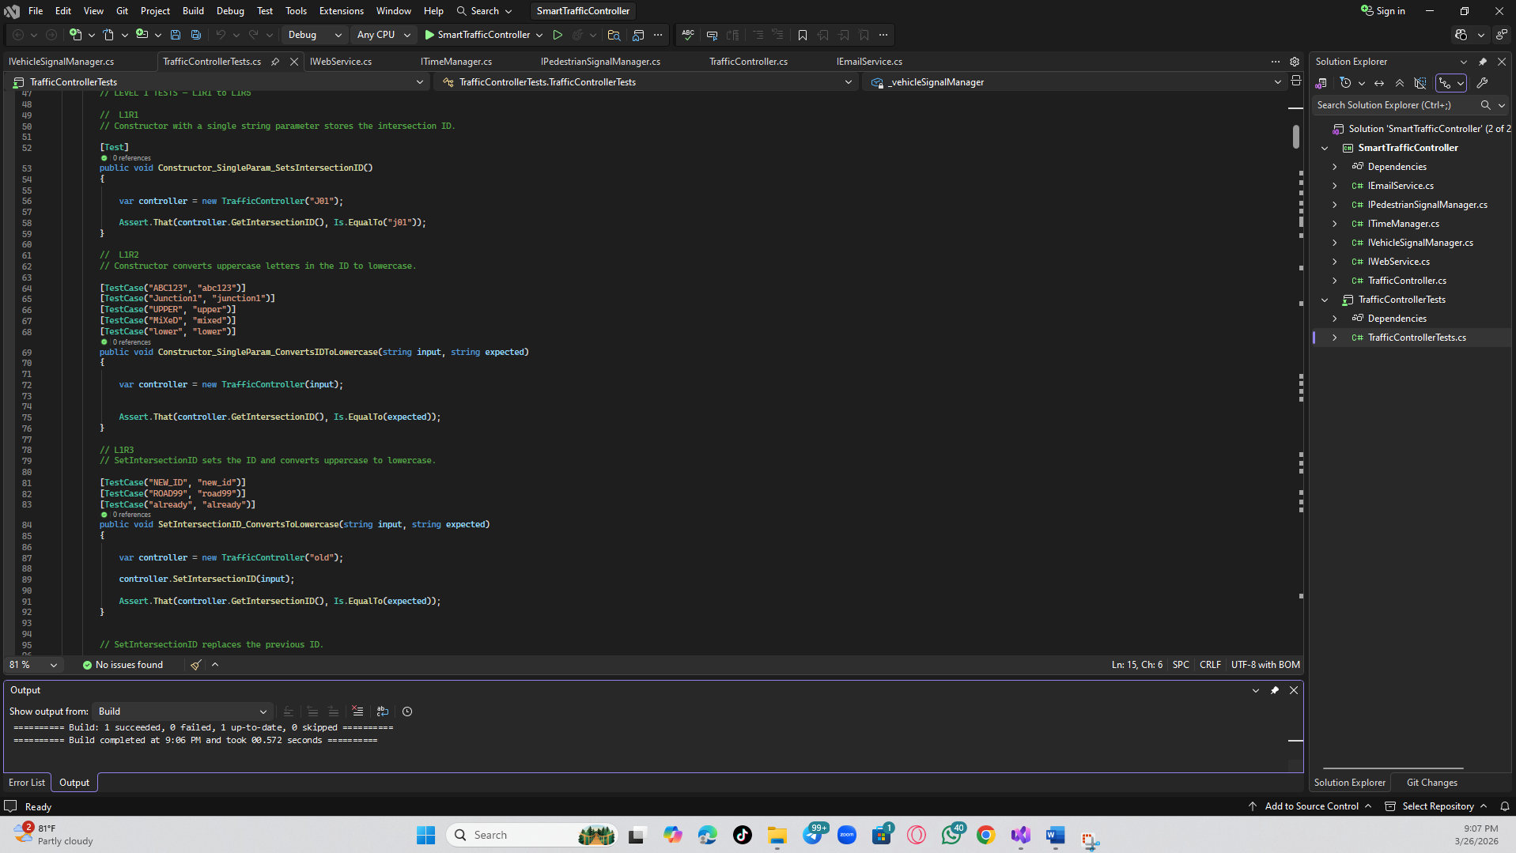
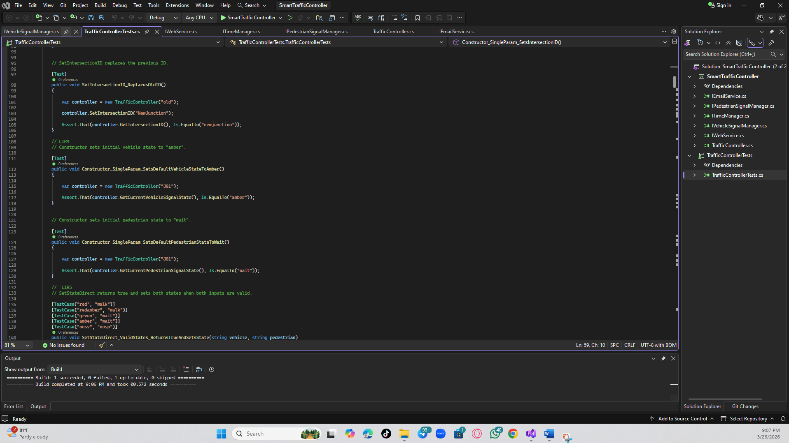

So What?
This project also made me realize more about TDD as a development practice not only a testing strategy. The nature of writing tests prior to implementation meant I had to specify the public interface of TrafficController prior to extensively writing any production code, which led to nicer method signatures and a better separation of concerns. Every unsuccessful test served as an accurate, implementable requirement and determined all the implementation choices during the project.

TDD Changed My Thinking
The greatest change of mindset was to think of a failing test as progress. In earlier projects I wrote tests and code as an after-thought. In this case all the red tests were exact specifications of the necessary behaviour. In the amber to red transition, I had not strictly applied the pedestrian state as “walk”, no matter what the caller argued to the contrary. This was immediately caught by a parameterised test and only a one line fix was necessary. In its absence this would have been a hidden bug.

NSubstitute and Mocking
The most useful technical knowledge acquired during this project is learning about NSubstitute 5.3.0. In Level 2 I was working with stubs, where the default method of a hardware method was to configure the return value with .Returns(). In Level 3 I advanced to complete mock object verification using .Received(1) to assert that a method was called once, .DidNotReceive to assert that a method was never called, and .When().Do() to simulate exception of the dependencies. I have now realized, not only in theory, but in practice, that stubs can be used to control inputs to the system under test, and mocks can be used to ensure that the system behaves with its dependencies in the expected manner.

Areas for Improvement
Multiple behaviours have been assessed in one of my earlier tests. They are more difficult to diagnose in the event of failure, but are useful in integration verification. I will also write more unit tests that are focused in future projects, one assertion to a test where possible. Along with [TestCase] parameterised tests, I also felt that they were stronger than I initially thought and will use them upfront instead of retrofitting on them later.

Now What?
I would use TDD in every future software development. The payback here is provided in faster debugging, better comprehension of requirements and confidence in the process of refactoring, which makes the investment of time in the upfront worthwhile. Even though the writing tests were slow at first, the development time was generally reduced since the bugs were identified at the earliest stage instead of being identified late.

Future Actions
- Use TDD in every subsequent C#-based project, at least one failing test must be written prior to any implementation code.
- Test coverage and any untested paths can be determined using coverlet.collector 6.0.4 (which is already present in the project).
- Train higher-order NSubstitute, especially argument matchers and call ordering verification, on more discriminative mock statements.
- Explore GitHub Actions to automatically run NUnit tests every commit to discipline TDD.
- Learn the pattern of State design, which would offer a more formalized way of how the transition logic of the TrafficController should be.

Conclusions
Designing an appropriate OO software solution: The project strengthened the development of classes with the public face in mind prior to internal implementation. The clean dependency inversion design of the five interface files IVehicleSignalManager, IPedestrianSignalManager, ITimeManager, IWebService, and IEmailService, have made TrafficController testable and extensible on its own.
Evaluating approaches to ensuring software quality: The best quality assurance method that I have utilized is TDD. The 65 unit tests discuss all 14 requirements in three priority levels. NSubstitute 5.3.0 mockt verifications comfirm that TrafficController communicates with its dependencies in the exact manner that is required by the specification.
Choosing and applying appropriate software development approaches, methods, and tools: TDD was particularly appropriate to this project, which was requirement-driven. NUnit 4.3.2 and NSubstitute 5.3.0 were a good C# test toolchain with the Arrange/Act/Assert pattern generating tests that were readable and maintainable.

Appendices

Requirements checklist
Level One | Level Two | Level Three
L1R1☒ | L2R1☒ | L3R1☒
L1R2☒ | L2R2☒ | L3R2☒
L1R3☒ | L2R3☒ | L3R3☒
L1R4☒ | L2R4☒ | L3R4☒
L1R5☒ |  | L3R5☒

Screenshots of any prompts and responses from GenAI tool

